SYSEN 5411 Fall 2025
Jonathan Lloyd
11/18/2025
Lab 8 Report – 1D Kalman Filter
Ultrasonic Noise vs Distance:
Tape Measure Distance (cm) | Ultrasonic Mean μ (cm) | Ultrasonic variance σ² (cm)
8 | 8.21 | 5.791e-5
23 | 23.12 | 7.224e-5
61 | 58.39 | 0.0081
102 | 98.85 | 0.0389
170 | 166.9 | 0.0314

1. Ultrasonic variance seems to increase proportionally to distance. This result matches intuition that the ultrasonic sensor is quite inaccurate at large distances due to the inverse square law of sound wave propagation, ambiguous returns from objects entering the beam cone at further distances, and variations in temperature and air turbulence along the cone path.
2. Measurement uncertainty R spiked drastically six times starting around t=9.5. The green line tracking Kalman filtered position successfully filtered out the majority of the ultrasonic sensor noise, lagging behind the initial spikes in both time and magnitude. The apparent instability in the control algorithm led the robot to oscillate in an attempt to correct the phantom errors; if the Kalman filter was running in real time, the encoder oscillation in blue would have been smaller.
3. Q vs R
Small Q vs R: As described in question 2, when the ultrasonic sensor becomes unstable and starts reporting phantom distances with greater sensor noise/uncertainty, the filter stays tighter to changes in the encoder readings, even though the reported state estimate is closer in vale to the sensor reading.
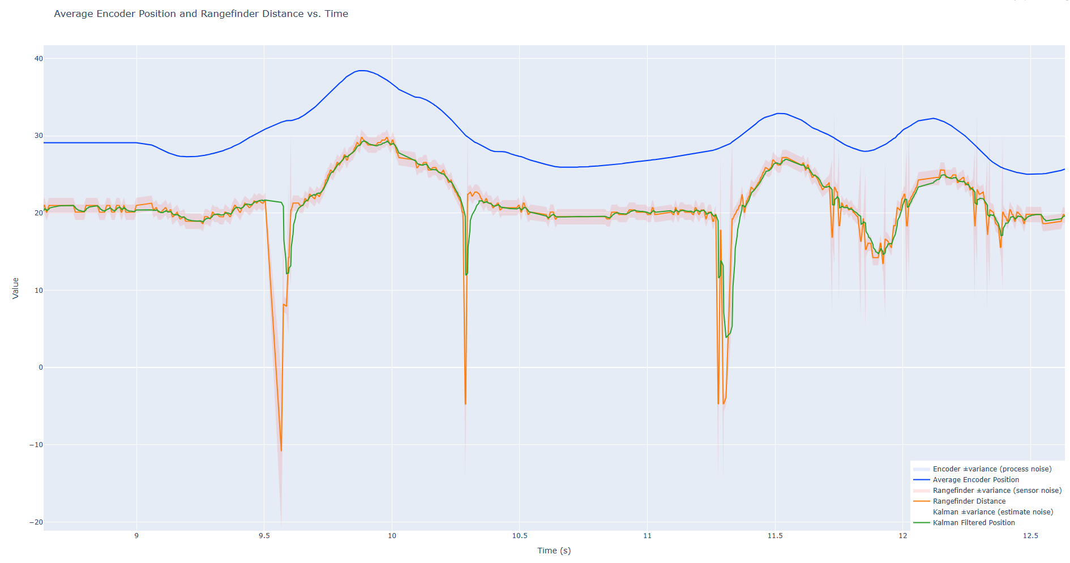
Large Q vs R: During the initial motion sequence of the robot overshooting and returning to the target, the filter state estimate tracks the ultrasonic sensor readings closer than the encoder readings.
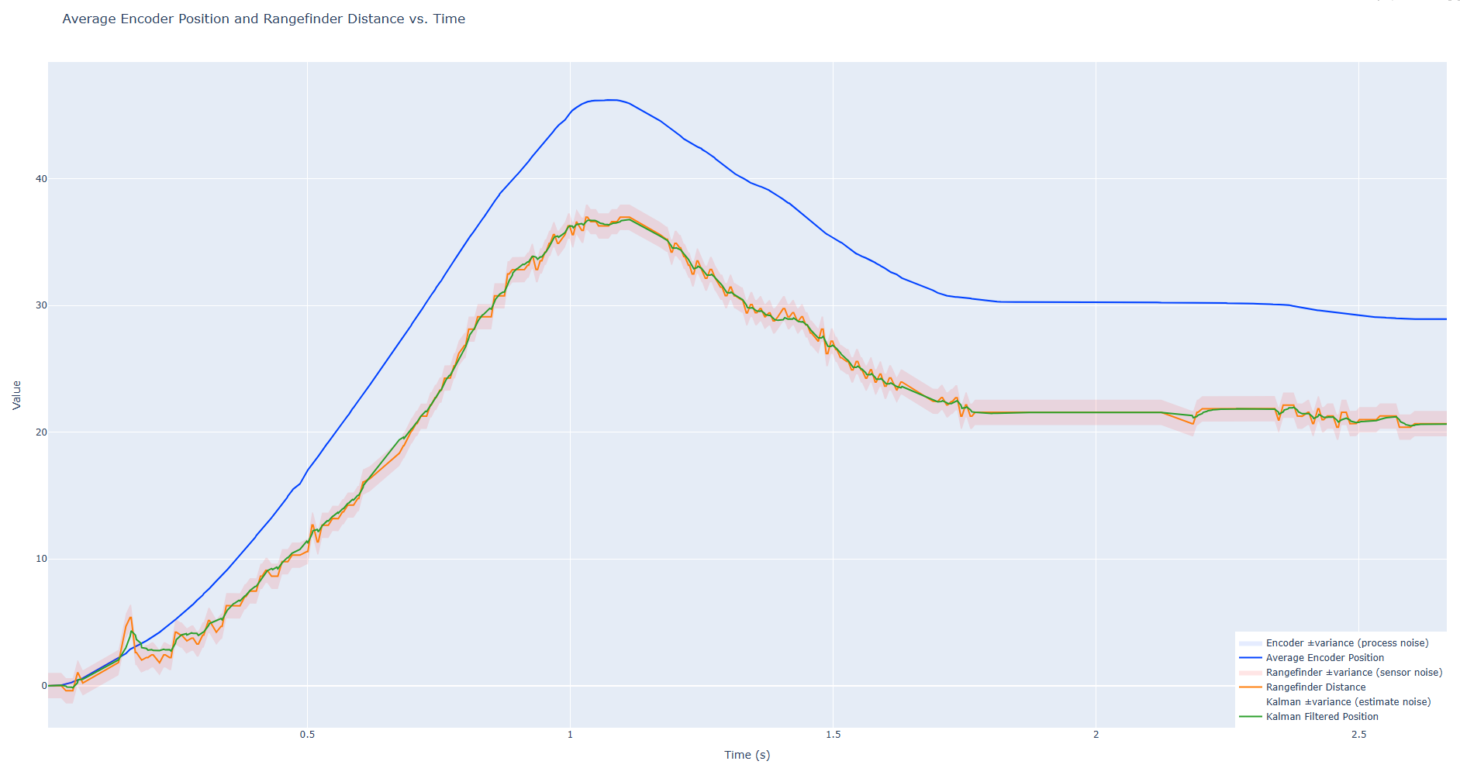
4. Filter Comparison
Both Kalman filters and complementary filters are methods of sensor fusion, but the major difference lies in the weighting of sensor data. Complementary filters use fixed, predetermined weights to fuse information from multiple sources. Kalman filter weights are initially set by the user but changing noise conditions or system states will drive changes to the weighting scheme to match.

